Lab Assignment – 3

Implement Logistic Regression and Polynomial Regression

Dataset: <https://www.kaggle.com/datasets/johnsmith88/heart-disease-dataset?resource=download>

Code:-



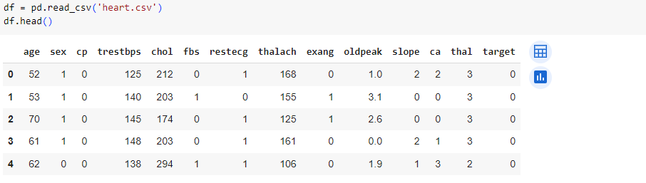

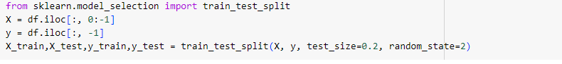

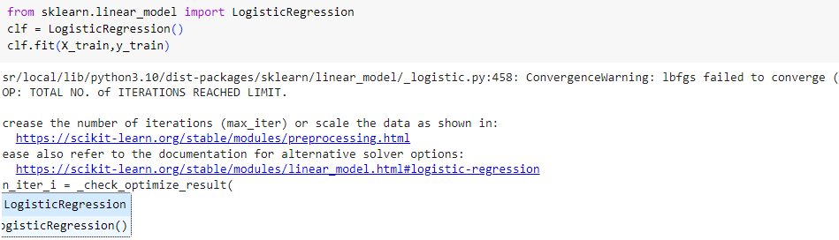

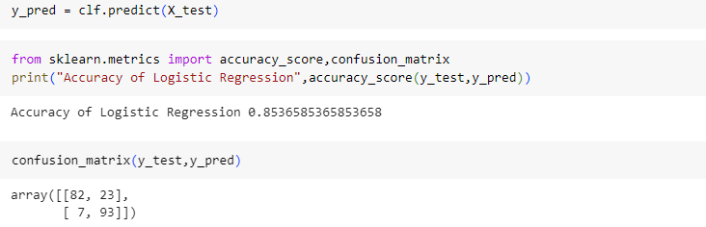

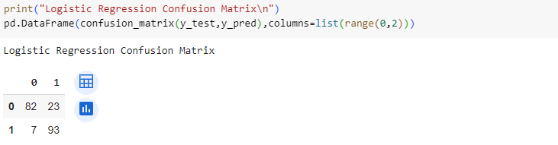

Interpretation:-

1. The confusion matrix provides a breakdown of the model's predictions versus the actual values. In this case:

* True Positives (TP): 82 - The model correctly predicted 82 instances of the positive class.
* False Positives (FP): 23 - The model incorrectly predicted 23 instances as positive when they were actually negative.
* False Negatives (FN): 7 - The model incorrectly predicted 7 instances as negative when they were actually positive.
* True Negatives (TN): 93 - The model correctly predicted 93 instances of the negative class.

1. The precision of 0.80 indicates that when the model predicts a positive outcome, it is correct 80% of the time.
2. The recall of 0.93 indicates that the model captures 93% of all actual positive instances.
3. The F1 score of 0.86 suggests that the model achieves a good balance between precision and recall.

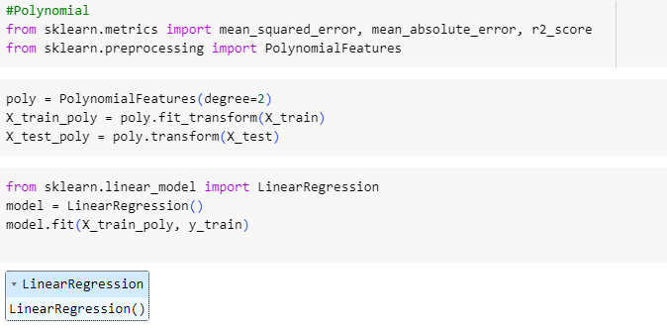

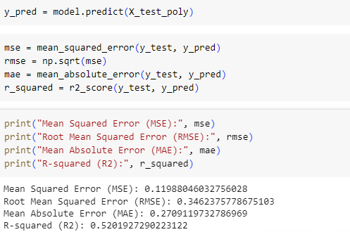

Interpretation:-

* The relatively low R-squared value (0.5202) suggests that the polynomial regression model explains only about 52.02% of the variance in the target variable. This indicates that there may be other factors not captured by the model that influence the target variable.
* The MSE, RMSE, and MAE values provide insights into the accuracy of the model's predictions. The lower these values, the better the model performance. In this case, the values are relatively low, indicating that the model's predictions are reasonably close to the actual values.